In this lesson we are going to play with tracker node we are gonna tracking object and texts from a video source file

This is a vary powerful tool probably one of the reason you want to use natron , something important to learn so first we are going to bring in some we want to track

So now we go to pixabay



Now this time we search for a video instead of image

We search bike for a video

So the footage we could use that has a movement in it you could use to. You can use it on stabilized footage to track and follow an object or both(maybe footage movement (who knows))

**Stabilised Footage**

**Stabilised footage** means video that has been processed to remove unwanted camera shake or jitter, so that it appears **smooth and steady**.

**Example:**

* If you shoot a video while walking, the raw footage might be shaky.
* After stabilization, the video looks like it was shot with a steady camera, like on a tripod or gimbal.

**How it's done:**

1. **In-camera stabilization** – Some cameras or phones have built-in features (optical or electronic) to stabilize video while recording.
2. **Post-production software** – Apps like Adobe Premiere Pro, Final Cut Pro, or even mobile apps like Google Photos can stabilize existing footage.

**Why it matters:**

* Stabilized footage looks more professional.
* It’s easier to watch and less distracting.
* It helps convey a sense of calm or control, which is useful in cinematic or documentary filmmaking.

Let me know if you want an example or how to do it using a specific app or tool.

I did not find the video which the teacher is using so I try another keyword that is bicycle riding



So we choose this video which teacher is using that is below

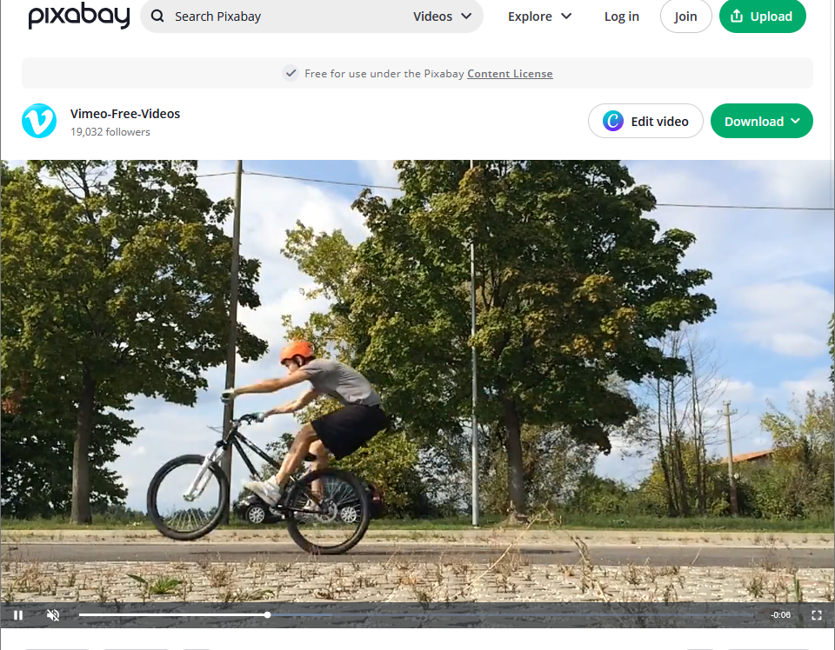

Third video is on tripod so we are only going to be tracking movement we don’t have to worry about shaky cam or stabilization so this is just gonna be a very basic tracking project

So we will free download this

So I downloaded this video of resolution 1280 X 720 as shown below

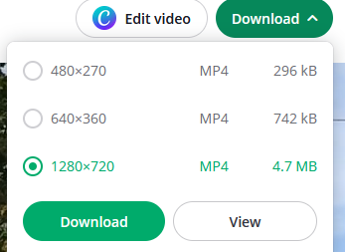

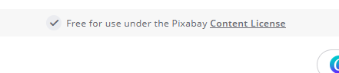

This video is free for use so it will not pose any problem in future

So we drag and drop the video file on the node graph so that the video is imported in natron

Now your node graph look like below

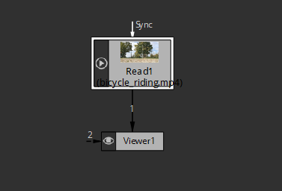

Now in Viewer panel you can view your imported video

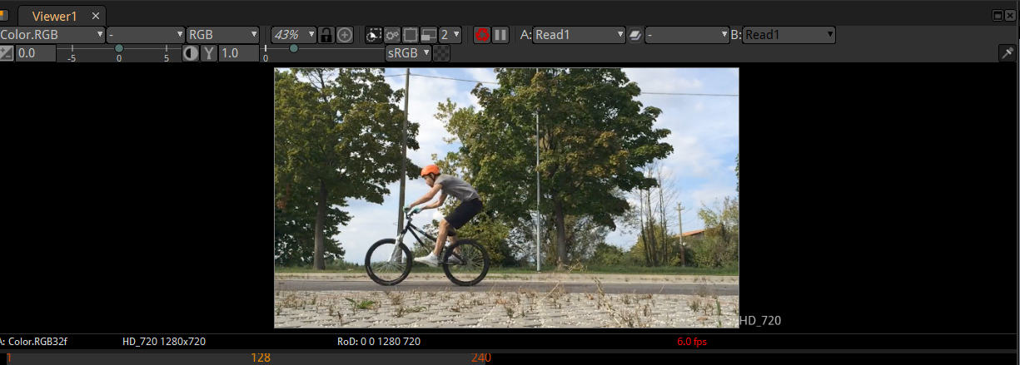

This video is pretty long so we are going to change that not in Read node but in project setting

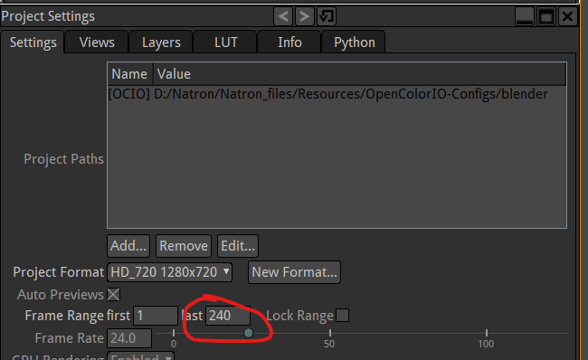

We set the marked field to 50 so that the video will become shorter

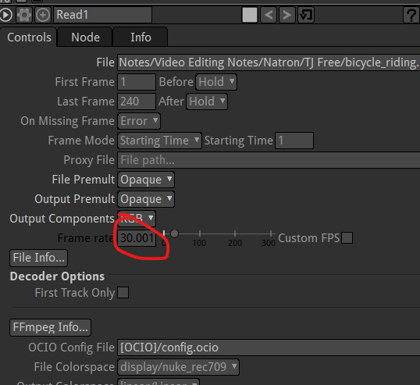

Now in read node you can see the from marked above that video has frame rate of 30 frames per second

So it gonna flash 30 picture of one thing to create movement

But our video project id set up for 24 frames per second

SO if we create anything like if we were to import like a different object or some text and try to merge it with this then we are gonna get the error message

Now suppose we bring a merge node and make the video our background abd then make any other object or text as foreground then we get the error as shown below saying video frame rate and the project frame does not match up

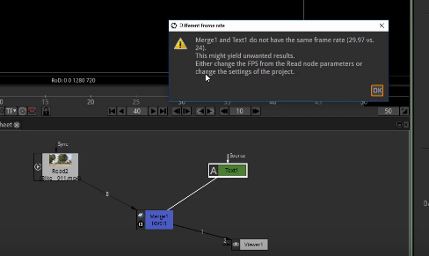

It is saying that you are trying to merge text that has been generated at 24 fps since that is our project but you are trying to merge it with a video at 30.01 frame rate so it’s just not gonna work ot will work actually

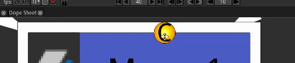

But we got a yellow dot on out merge node as shoen below to indicate an error (may be it shows only on this )

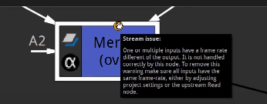

So when we hover over this yellow mark then it will show Strem issues as shown above

Because its different frame rate of the vidoes so to fix that anyway we make both of them equal ‘

Now we want have any issues

Now I integrate video with text now it look like below

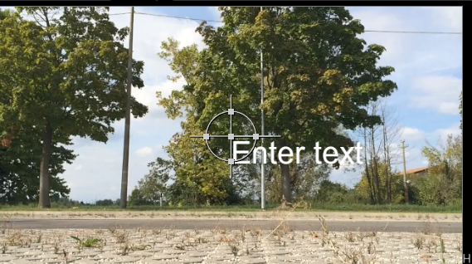

Now we go to text property and then set its text to bikeguy

If we play the video then the bikeGuy will be right in the middle of the viewport panel

SO If we just wanted to make a title then we could keep the at the top and middle horizontally

4:20

Which you might want to stay in the middle of your video as shown below

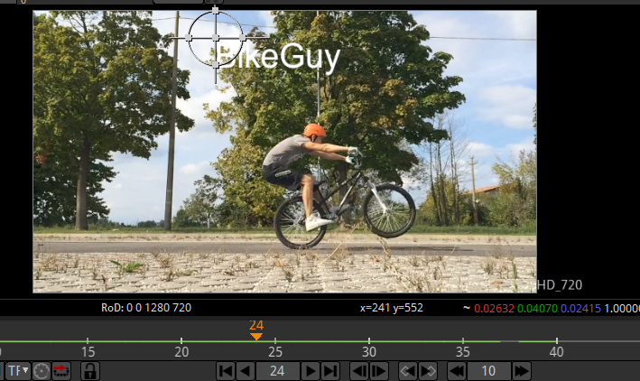

But what we really wanted to do is follow along with him So when the cycler runs then the text should also move with him that’s probably an effect that you have seen before used in videos it’s kind of cool thing so but we are doing now when the cycler moves then the text will stay at that position so one way we could use this is when we are gonna be using the tracker node to accomplish this

Now teacher is saying that you could do this with the things you already learnt by just setting keyframed for center x and y for the text as marked below

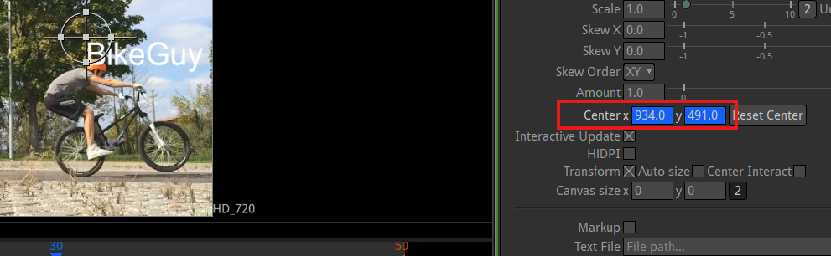

Now frame by frame we will move our text according to the cycler manually but its not we are not using tracker node we are not tracking him we are just manually moving the text which is a tedious way to do it we are 50 frames we could be doing thousand of frames you have to go to everything manually and move this text manually very tedious very time consuming so its much faster way to do it do that I am gonna select the text node press delete key. We will delete that and lets bring in a tracker

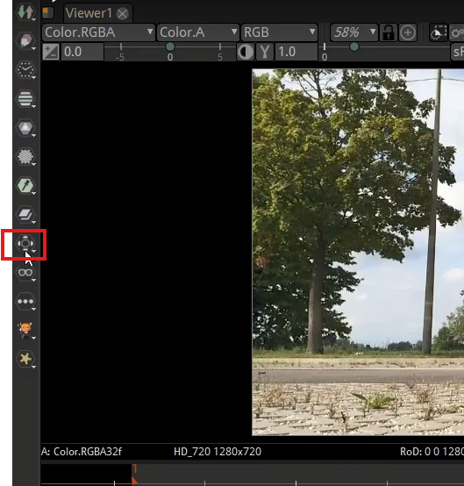

So we will click on Transform tools and now a submenu will be opened and then go to Tracker option

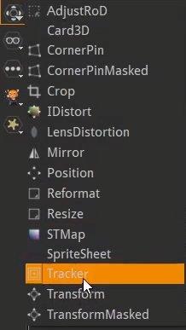

Now in node graph will be like below

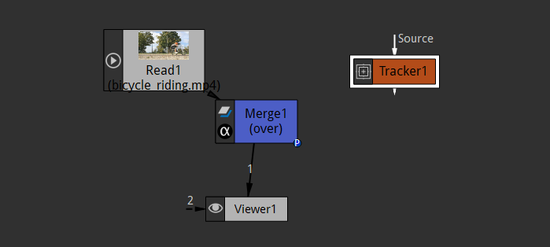

Now we have but It is does not detect anything we want the source be to our video here but teacher is not gonna do it just yet Teacher want to show that you can use this tracker even wirth its not tied to anything so now scroll to zoom in viewer tab

And a good point that we are gonna choose to track is that his ear we have the ear as marked below

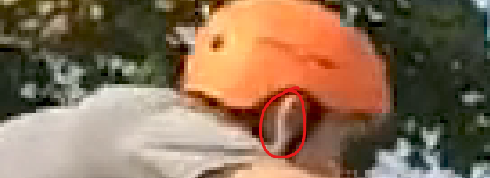

we have ear a nice contrast between the helmet and the ear and his head stays pretty constant like in the same place relative to him and the bike

we could see the tracker properties as marked below

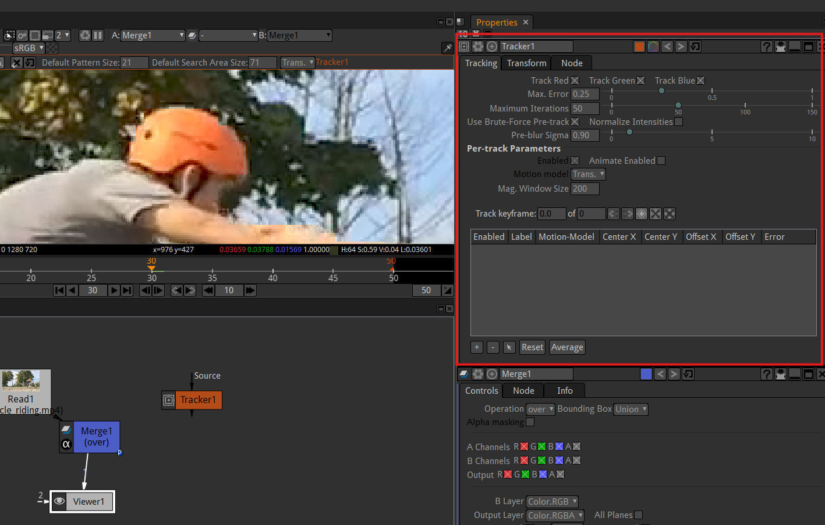

So now we see some new tools in the viewport as marked below

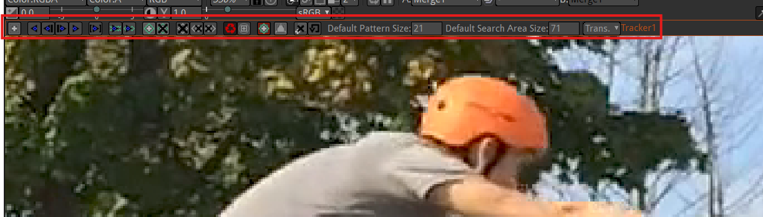

They come with the tracker they were not before

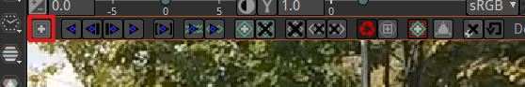

So the above marked tool is add track tool

But it will not work because in node graph we set all the output of all node to the tracker node and then attach tracker node to the viewer node as shown below( It happens in modern but in older you did not need to attach the tracker to all the output of nodes and they could be a separate independent node)

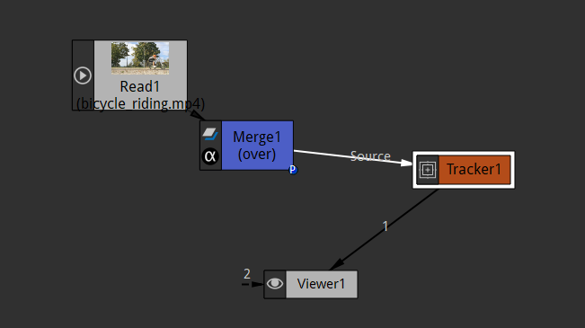



Now if we again click on the marked above( its name is add track ). Now you can see with you pointer there is another ison that is green square and + symbol inside it

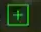

And now we can create a new point to track on any point in the footage

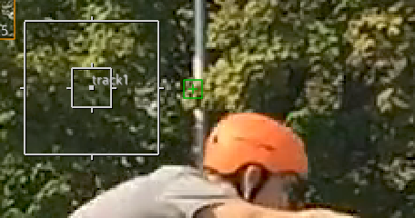

6:50

Now we can see above we are tracking a tree

Now in tracker properties

You can see that track 1 is added in the list of trcks(I think so )as marked below

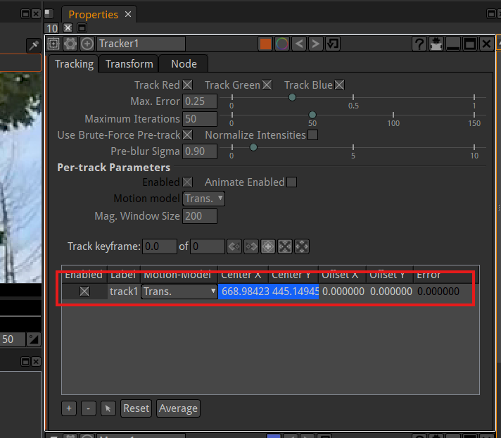

Now click on another part of the image a new track will be there as shown below and now you can see track 2 is added to the list as marked below

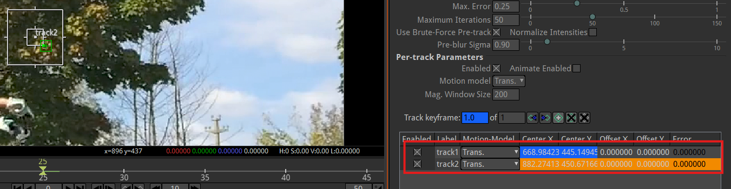

Now track 2 is new one so track 1 disappears and you can also say track 2 is selected

Now if we again click on helmet then there is new track symbol and then you can see track3 is added to the list as marked below

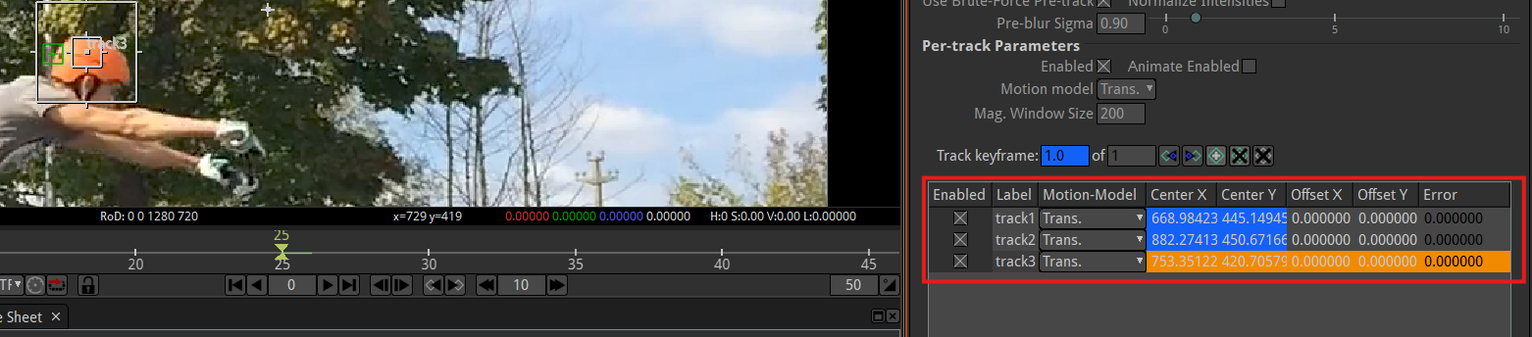

So now we have three different points that we are tracking on this lesson .Teacher did to show us because probably something that might confuse us(who knows)

Now in the tracks list box select the track you want to delete the track

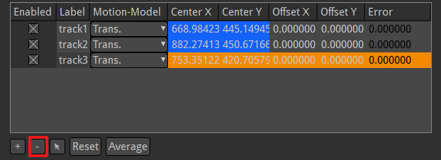

Abd then click on the marked one to delete the marked track Now we delete all three of those

So now we add a new track and add it as marked below at the ear as shown below

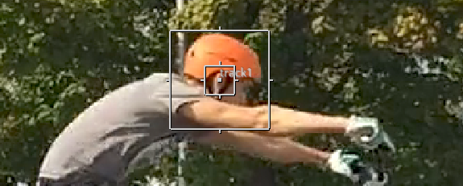

If we click on anywhere even inside the box of track 1 then track 2 will be created but we don’t want to do it just we only will work with one track in this lesson so now you can see that in tracks list you can see one track as shown below in the tracker properties

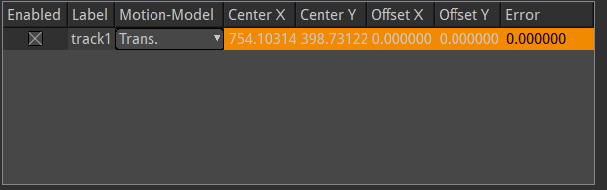

So this is perfect the track1 is showing right. In the middle of the ear we haver the box of tracking and also have large box that will adjust it little bit

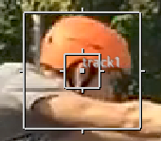

but for right now just on the frame everything seems pretty good where it needs to be So now we click the forward frame button as marked below

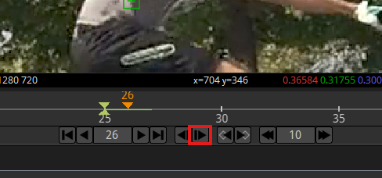

Now you can see that the tracker stays in its place bit the subject moved away in our video

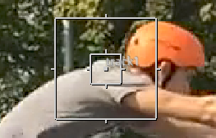

Again click on the add tracker option in viewer to disable it

Now with your pointer click on the middle of the box as marked below

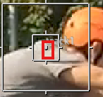

Now drag and drop on the ear again Now it will look like below

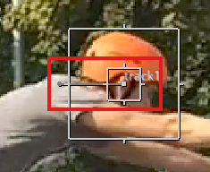

Now we can see a gray line and now if we go back

And now if we back and forth by one frame in the timeline then we will observe that between two frames which were frames right next to each other we created two tracking points as shown in the timeline

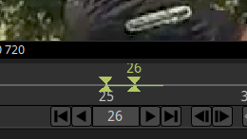

If we move forward and generate a third one as shown below

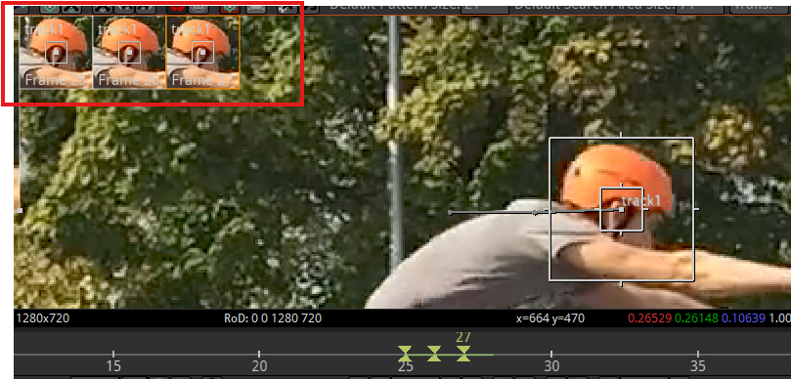

This is sort as tedious as the text example the teacher gave us earlier we are still manually tracking every point but it can be done and you have to manually set up like this

Now marked above is the list of frames where your current tracker point made points

Now we add fourth point by going one frame backward to the frame where you add the tracker point first time as shown below

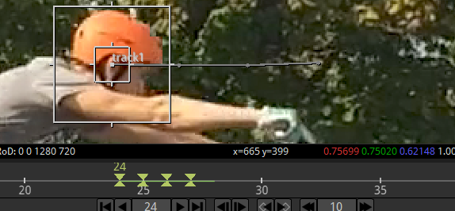

Now we have four points that we have manually created

Sometimes we do mistake like in different frame we add track 2 instead of dragging our track 1

So always make sure that in TrackBox there should be track name which yo9u were dragging

Don’t create new points when you are just trying to track a single point

Ok so now we have this we can see cycler is moving forward and what this grey line joining track box position in different frame This grey line is the line where we can map our text to or map any object to so that thy will follow this line. But as teacher told he will tell us the faster way to do this tracking than just doing it manually

10:06

So lets go ahead and delete this track in the track list and go to and now add a new tracker point on the ear

Now what we need to make the outside box of a tracker larger we need to make it like almost large by dragging along the vertices

SO noe this large box giving the information on all the pixel around so it can look and get a good reference point

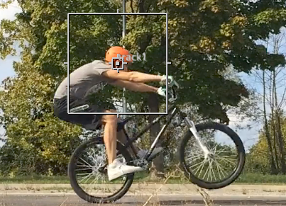

If this box is too smaller. Sometimes you want smaller because you don’t wean to get confused (who knows) but if its too small as shown below

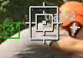

then its not gonna be able to automatically track for us so we need to make it bigger then what we want to do is just go to blue button beside the add tracker point tools as marked below

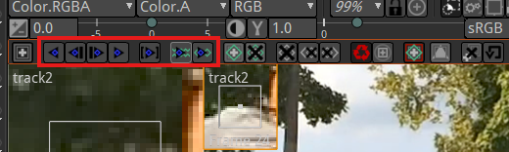

They are just like blue buttons se we have just like play button that Is the third button in the marked.

If you hover it it tells us that it actually track to the next node

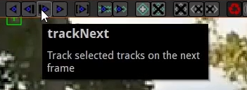

So if we hit that then hopefully track forward for us

Teacher did a mistake such that he did not attach the tracker node to the output of nodes due to which tracker is tracking a black screen as shown below

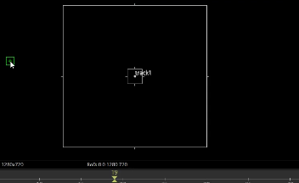

but I did not do mistake because in modern Natron we had to add tracker otherwise we could not add tracker point to the video

and since t is tracking the black screen there is nothing to track or follow Its just the blackness what the tracker is seeing

In teacher’s time the tracker could be attached to the read node by taking read node as a source node but now we have to attach the tracker node to the output of nodes as i have done shown below

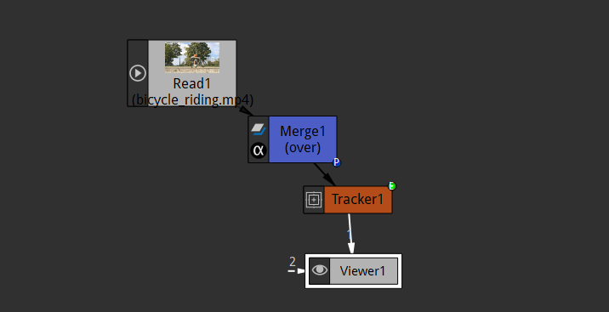

Now if we click on track next button now we go to new frame and automatically create this grey line as shown below

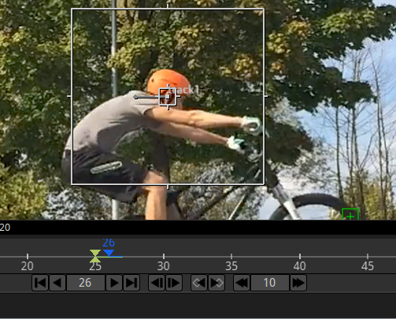

It automatically tracks for us for the next frame So we are not having to drag and move it. Its automatically doing it when we click on track next button

If I again click on the next one

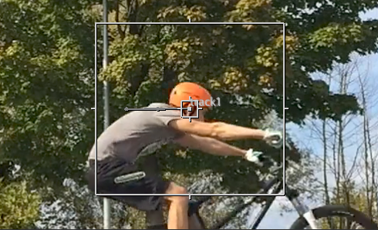

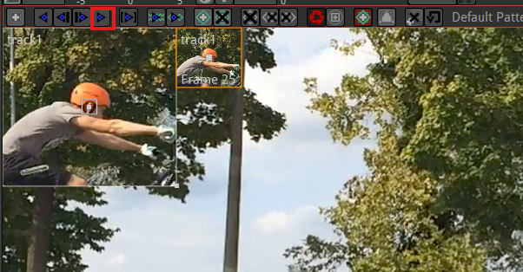

If click on the marked above we call it TrackFW it will make track all the way forward as far our last frame as shoen below

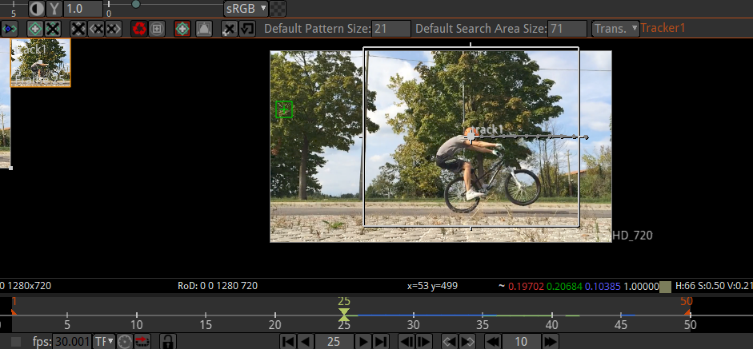

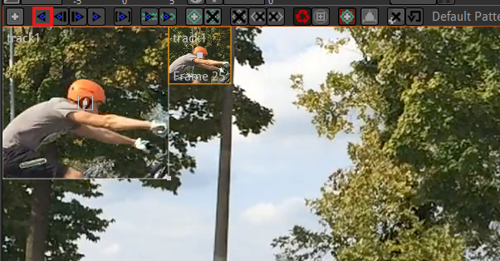

If you click on the marked above to then it will tack all the way in reverse to the first frame

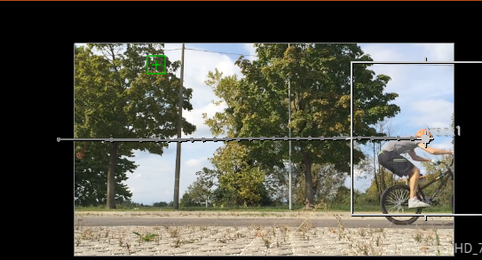

It may give problem while tracking as you can see above I cannot track fully track it properly

So now it’s tracked all the way backward so this by drawing this the box around Natron is looking at all the different pixels around this box and its figuring out where that point is in next or previous frame (who know)without having to tell it to every frame so we have just created a single track that is single point to track in this video so if we are going to the very beginning of this video and play we will see it is doing what we want to do it’s tracking him Its’s this box is staying around and finding out where he is at which is super cool now how do we use this data so it’s tracking but kind of harder part is actually getting it to apply to an object properly so we have different tab in tracker propertles

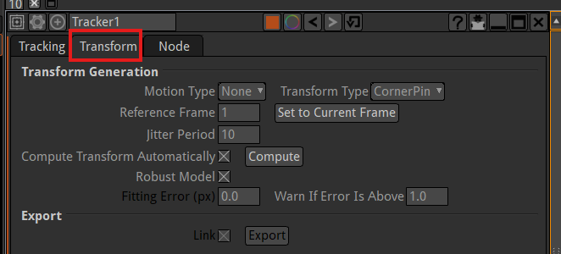

As marked above we have Transform tab if we left click on it then. It gives us some option for this tracker so right now all we have done is created a point we have successfully tied the tracker to our source video and its been able to create tracking points but this but tracker does not now what it is trying to do

14:05

So what we want to do is tell okay So Now in transform tab you can see the motion type as marked below

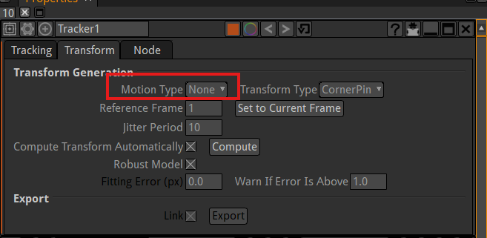

Now we click on the Motion type field then a submenu will be opened as shewn below

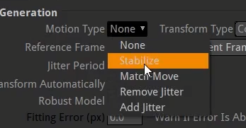

WE don’t choose stabilize because it is used when you have a shaky footage (who knows) we are going to choose match move so we want to match the movement of this subject in the video

And in transform type as marked below choose

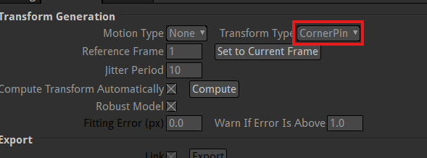

And then in submenu we choose transform as marked below

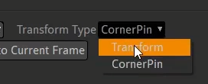

Because we have a single point(who knows maybe it is talking about tracking point )

Now in the same tab go to below you can see the things are updated as marked below

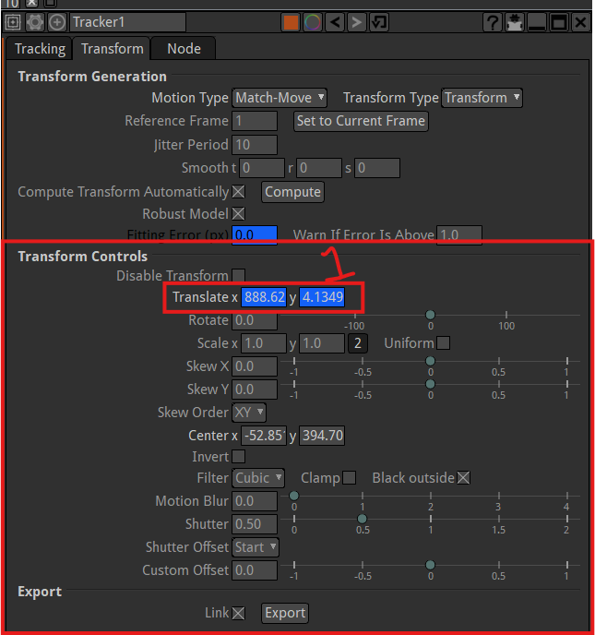

We keep everything the same the only thing we are going to change is translate x and y as marked 1

As that is the only thing really moving in this is this track point

The blue line in the timeline tells that there is keyframes in that portion of timeline



And we are basically moving our track point we not doing anything we are just translating, we are not doing skew or any other thing

Now we click on export button as marked below

Now when you click on it then in node graph a transform node is generated as you can see marked below

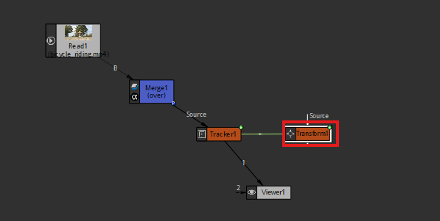

Now this transform node contains all the information of the transform of tracking point

Now remember we used transform node to change like shape of something or change where is at the screen Well now we have transform node that we can use